11.25 FRAUD RISK ASSESSMENT

The following describes the functionality and features included in Probe Audit Premium+

Objective

The objective of this document is to identify and assess the risks of material misstatement in the financial statements due to fraud, by evaluating whether fraud risk factors relating to incentives, opportunities and rationalisations are present, and to determine overall responses to the assessed risks of fraud.

The following key concepts of the Probe Audit Premium+ Methodology are set in this document:
- Assessment of fraud risk factors through the incentive, opportunity, and rationalisation framework (ISA 240)
- Presumed significant risk of management override of controls
- Identification of fraud risks that flow to the overall risk assessment and drive specific audit responses

Document placement
Document 11.25 – Fraud risk assessment can be found in the Planning and risk assessment procedures folder in the Caseware document manager.
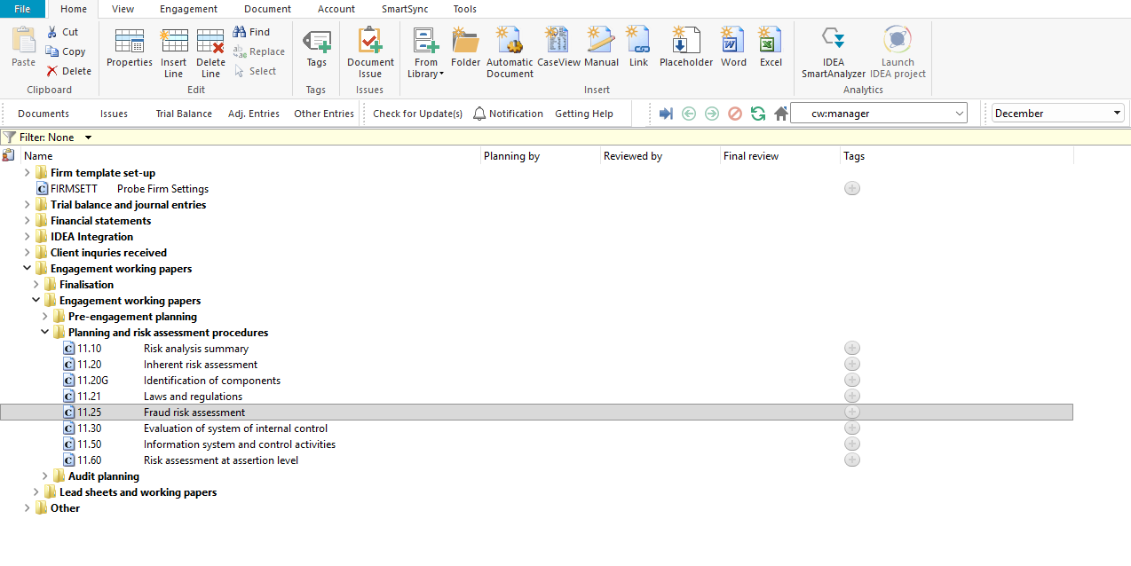

Document content
This document is designed to be a questionnaire type document with space for a comment or further description.
The fraud risk factors in this document are structured around the three conditions generally present when fraud occurs, as described in ISA 240:
- Incentive – pressure or motive to commit fraud
- Opportunity – circumstances that allow fraud to be perpetrated
- Rationalisation – attitude or ethical values that allow individuals to justify a fraudulent act
This document is divided into different bookmarks in the document map to assist you with the fraud risk assessment process:
- Risk assessment procedures
- Incentive
- Opportunity
- Rationalisation
- Identified risks
- Conclusion
- Risk of material misstatement
[INSERT SCREENSHOT: Document map showing bookmarks]

Identified risks
The Identified risks table is pre-populated with the presumed risk of management override of controls in terms of ISA 240.31 and ISA 240.32. Management is in a unique position to perpetrate fraud because of management’s ability to manipulate accounting records and prepare fraudulent financial statements by overriding controls. This presumed significant risk cannot be removed.
When recording a fraud risk using the RECORD BUTTON, all the input fields in the risk dialogue must be completed before submitting the risk. Upon submission, the information entered in the risk dialogue will populate the Identified risks table in this document and 12.20 – Audit plan and strategy.

Column | Input required | Outcome
Source | Insert the reference of the document where the risk was identified. You can double-click on the source input cell to insert the previous document you worked on or type in the source document. | The input will populate the risk tables in this document and 12.20 – Audit plan and strategy.
Risk | Insert a brief description of the risk identified. | The input will populate the risk tables in this document and 12.20 – Audit plan and strategy. It also pulls through to 02.00 – Partner sign-off.
ROMM considerations | Document further evidence used to assess the identified risk of material misstatement (ROMM) at financial statement level. | The input will populate the risk tables in this document and 12.20 – Audit plan and strategy.
Significant risk | This selection will appear when the ROMM is assessed as “High”. Select whether the risk is assessed as a significant risk. | When a risk is assessed as significant, the risk tables in this document and 12.20 – Audit plan and strategy are updated. This will also result in an extended risk table being shown in 02.00 – Partner sign-off.
ROMM | Select low, medium or high based on your assessment of ROMM. | The input will populate the risk tables in this document and 12.20 – Audit plan and strategy.
Overall response | Select overall response(s) to the identified risk. | The input will populate the risk tables in this document and 12.20 – Audit plan and strategy. An additional overall response section will be included on this document and selections automated based on the selections made with the Risk Dialog. When the risk is significant, this will also update the risk table in 02.00 – Partner sign-off.

Layout
Column | Input required | Outcome
Risk assessment procedures
Type of procedures | No input is required in this column. | No impact on the engagement file.
Select | Select the risk assessment procedures performed by clicking on the relevant tick box (i.e. inquiries, observations and/or inspections). | No impact on the engagement file.
Describe the source(s) from which information was obtained | Insert a short description of the sources of information from which the understanding was obtained or the procedures performed. When inquiries is selected, record the name and designation of the interviewee and the date of the inquiry. | No impact on the engagement file.
Incentive / Opportunity / Rationalisation
Question | No input is required in this column. | No impact on the engagement file.
Yes/No | Answer the question by selecting from the “Yes / No” drop-down box. | By answering the questions, the engagement team documents their consideration of whether fraud risk factors are present. Responses may indicate the need to raise a fraud risk.
Description | Include a short description, if necessary, to substantiate or expand on the “Yes / No” answer selected. | No impact on the engagement file.
Risk | Raise a risk or event, if necessary, relating to the question or the responses reflected. | A risk or event will be recorded in the relevant document. The engagement file will then prompt the engagement team for appropriate responses to the risk or event recorded. If the risk raised is a fraud risk at financial statement level, the Identified risks table in this document will be activated.
Conclusion
Conclusion questions | Answer the conclusion questions to confirm whether the results of the fraud risk assessment procedures indicate risks that management would have been expected to identify but failed to do so, and whether any risks affect the assessment of risks at assertion level. | When risks affect the assessment of risks at assertion level, the engagement team should consider the impact on 11.60 – Risk assessment at assertion level.
Risk of material misstatement | Conclude on the fraud risk at financial statement level assessment. | The fraud risk at financial statement level assessment is documented for the engagement.

Document outcomes
You must conclude on the fraud risk at financial statement level. The presumed risk of management override of controls (ISA 240.31 and ISA 240.32) is pre-populated as a significant risk and cannot be removed. Additional fraud risks should be raised where appropriate based on your evaluation of fraud risk factors. Where fraud risks are raised, overall responses must be documented.

Group Audits
When the engagement type was selected as ‘Group Audit Single’ or ‘Group Audit Multiple’, questions are modified for the separate group audit engagement file.
Additional questions were added for group audit engagement to:
- Identify components for planning and performing of audit procedures;
- Determine expected involvement of component auditors in risk assessment procedures and further audit procedures;
- Evaluate access to components and component auditors; and
- Determine whether there is any indication that the group auditor will not be able to be sufficiently and appropriately involved in the work of the component auditor.
Some questions include red warnings or blue text in the description column. Follow the red warnings that inform you where key information should be recorded and the blue text in the description column that advises you where the understanding may be documented.

IN CONCLUSION
Features
The following features are available in the document:
- Insert or delete a comment, see page F3
- Insert or delete a row at the end, see page F5
- Record a risk or event, see page F10
- Core vs Extended, see page F15
- Guidance, see page F16
- Freeze, see page F19

